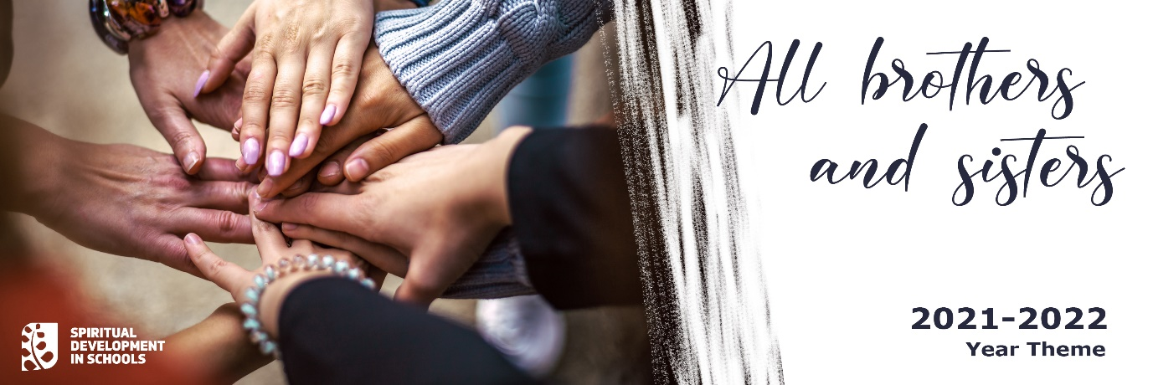
Prayers of the Faithful
- Dear Lord, at the beginning of this Scholastic Year, we would like to thank you for the many blessings you have given us and for your protection during the pandemic. We pray for a better year; for a safe return to our classrooms; for the health of students, teachers and school staff under pressure to make difficult decisions; and for parents exhausted by the uncertainty and constantly changing plans. Give us the courage, Lord, to trust in your love and mercy.
Lord hear us.
- Dear Lord, we would like to pray for all students. Give us the courage to accept the new challenges and exciting opportunities which come our way so we can develop our talents to make the world a better place.
Lord hear us
- Merciful and loving God, we pray for all those who are suffering hunger, loneliness, , injustice, war or discrimination. Help us, dear Lord, to disperse the darkness by bringing bring love, peace and kindness to the people we meet every day.
Lord hear us
- Mother Mary, we ask you to bless all families and to protect them from all harm. Help them to spend quality time together, to find time to listen to each other as well as to pray together.
Mary hear us

